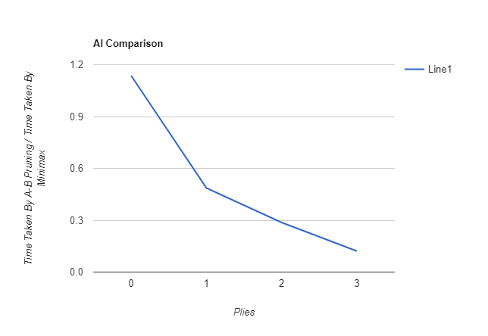

**What trends are visible on the graph? What does it reveal about the different AIs?**

As the number of plies goes up, the difference between the time taken by each AI3 increases. With 3 plies, the time taken by the Alpha-Beta Pruning AI is only about a tenth of the time taken by the Minimax AI created in class. As the New AI is able to eliminate paths, it takes significantly less time to process.

**What is the win-ratio of Alpha-Beta? Why?**

The win-loss ratio at 0 – 1 plies is about 1:1, but when the plies increases to 3, there starts to be a difference, with the Minimax AI doing slightly better. This may be because some good paths are eliminated by the algorithm.

**Which AI would you choose to use in a tournament? What value of ply would you use? Why?**

I would choose the Minimax AI in a tournament, even if it is not as Efficient as there is no risk of the AI eliminating a path which maybe better than the chosen one.